C5 Cycle Challenge Saturday 9th July 2016

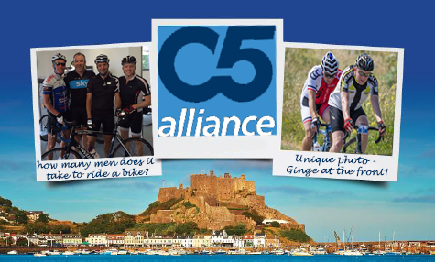

Welcome to the C5 Cycle 2016

In 2015 C5 in conjunction with Blanca Palacin rode in memory of our friend Neil “Ginge” Hussey, which was a fantastic, overwhelming tribute and a huge accomplishment enjoyed by all that took part.
We ask ourselves then why not again this year!! So here goes, Saturday July 9th from 09.00am all riders will leave from Gorey pier and can choose between the 50 or 100k challenge.

The Jersey Tour Ride will have two elements (100km for the more experienced cyclist) or (50km for the recreational amongst you), and will take place on Saturday 9th July 2016 between 9:00am - 18:00pm. C5 will cover ride entry fee plus food and drink on the day. We will toast a drink to Neil once the event has closed.

VENUE

Gorey Pier,
Gorey,
Jersey,
JE3 9EW

DISTANCES

Challenge – 50 kilometres
Pro – 100 kilometres

TOUR RIDE START

All riders will start at Gorey Pier
8.00am – Registration desks open
8.50am – Riders begin to assemble in muster area (50m before start line)
9.00am – Riders depart in their chosen distance groups
6.00pm – Last riders to be finished

ROUTE SIGNAGE

Both routes will be comprehensively marked with our distinctive arrow boards. Please make sure that you are familiar with the route.

100KM ONLY 50KM ONLY

50 and 100KM SHARED ROUTE

100KM Route Map
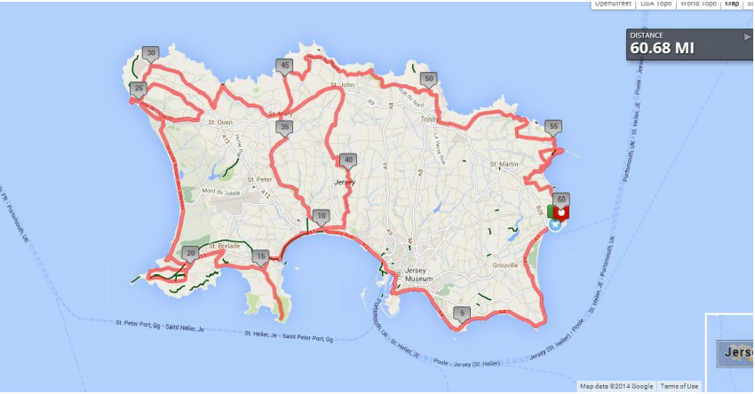

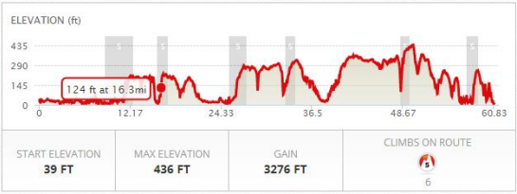

www.mapmyride.com/je/saint-helier-jersey-general/jfoc-sportive-100k-route-329097037

Detailed route information can be found here;

http://jersey.com/Documents/Cycling/Jersey-Festival-of-Cycling-Pearl-Izumi-Jersey-Tour-Ride- 100km.pdf

50KM Route Map
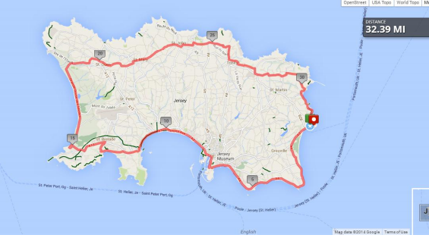

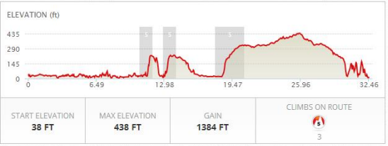

http://www.mapmyride.com/je/saint-helier-jersey-general/jfoc-sportive-50k-route-329106817

Detailed route information can be found here;

http://jersey.com/Documents/Cycling/Jersey-Festival-of-Cycling-Pearl-Izumi-Jersey-TourRide-50km.pdf

RIDING STANDARDS AND BEHAVIOUR

In entering the C5 Ride the participant agrees to obey the rules of the road.
All participants need to understand and accept the following;
- Dispose of all litter responsibility.
- That cyclo-sportives are non-competitive events and should in no way be ridden in a competitive manner.
- Be aware of your fellow cyclists; ride in single file as appropriate and no more than two abreast at other times.
- Use the cycle route along Victoria Avenue in St Helier with extreme caution.
- Do not listen to headphones or use mobile phones whilst riding.
- That the management of hazards, terrain and judgement of traffic whilst riding rest entirely with the participant.
- Anti-social, inconsiderate, abusive or other unreasonable conduct may result in the participant being withdrawn from the event.
- The wearing of helmets is mandatory.
- All participants should ensure they ride in a self-sufficient manner, e.g. take their own food, money and means of navigation and means of communication to cover unforeseen circumstances that may leave them without the aforementioned support.

MEDICAL AND PHYSICAL FITNESS

The participant confirms by entering the event that he/she is medically fit to do so and that no obligation transfers to the organisers to ensure that this is the case. The participant also accepts that adequate preparation and training are required to complete such endurance events.

JUNIOR RIDERS

Junior riders are deemed to be any rider under the age of 18 years on the day of the event. No parental responsibility attaches to the organiser at any time. Any junior who enters agrees to ride in the company of a parent, guardian or other responsible adult at all times during the event. All riders under the age of 18 will need to provide a completed British Cycling parental consent form.

FOOD AND DRINK
Upon completion of the event, C5 will be hosting a table at The Moorings, Gorey Pier. We will provide light refreshments and this will be our opportunity to toast our good friend Neil (Ginge). We would be delighted if you could stay for this.,

LITTER
Ensure all litter is disposed of properly either in rubbish bins and the start/finish or at the feed station.

TIMING
We understand that some riders want the opportunity to track their times and speed, we have set up a route in Strava, which upon completion of the race you can view your results. For those of you who are not registered on Strava, this is an application that you can download free of charge.
www.strava.com

CONTACT DETAILS

For general enquiries please contact;
Rose.McCloskey@c5alliance.com
C5 Alliance
25-26 Esplanade
St Helier
Jersey
JE2 3QA
+44 77977 88065

